

Name of Student: Karan Kr. Pal PRN: 25070122098
Subject: Programming with Java Sem: III Batch:25-29
Assignment No: 3
TITLE: Develop a Java application demonstrating method overloading and the use of static
variables, methods in class design.

Problem Statement: Develop a Java application demonstrating method overloading and the use of static variables, methods in class design.
Learning Objectives: To implement method overloading and use static variables and methods in Java programs.
Theory: Method overloading allows multiple methods to have the same name with different parameter lists, enabling compile-time polymorphism. The static keyword is used for variables and methods that belong to the class instead of individual objects. Static members share common data among all objects and reduce memory usage. These concepts improve code flexibility, readability, and efficient resource management.
- Develop a Calculator program using overloaded methods for addition of integers and decimals. Use a static variable to count calculations.
class Calculator { static int count = 0; int add(int a, int b) {
count++; return a + b;
}
double add(double a, double b) { count++;

return a + b;
}
public static void main(String[] args) { Calculator c = new Calculator();
System.out.println("Integer Addition: " + c.add(25, 35)); System.out.println("Decimal Addition: " + c.add(20.5, 9.5)); System.out.println("Total Calculations: " + count);
}
}

OUTPUT
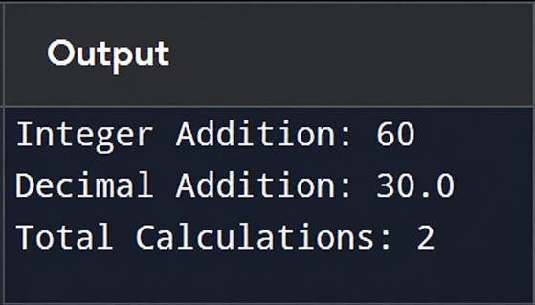

- Develop a Restaurant Billing Application where overloaded methods calculate bills for dine-in, takeaway, and delivery orders, while static variables track total orders.
class Restaurant {
static int totalOrders = 0; double bill(double amount) {
totalOrders++; return amount;
}

double bill(double amount, double packingCharge) { totalOrders++;
return amount + packingCharge;
}

double bill(double amount, double deliveryCharge, double tax) { totalOrders++;
return amount + deliveryCharge + tax;
}
public static void main(String[] args) { Restaurant r = new Restaurant();
System.out.println("Dine-in Bill: " + r.bill(100)); System.out.println("Takeaway Bill: " + r.bill(50, 20)); System.out.println("Delivery Bill: " + r.bill(50, 100, 50));

System.out.println("Total Orders: " + totalOrders);
}
}

OUTPUT
